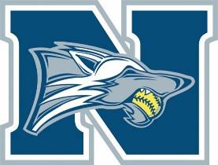
Sponsorship Form
The North Paulding Lady Wolfpack Softball team is a strong competitor in Paulding County and the State of Georgia. The Lady Wolfpack owe a large part of their success to the community because of monetary donations and support. Your monetary donation will assist with equipment, uniforms, and field improvements. The Lady Wolfpack coaches and players thank you in advance for your donations and support.
I, ________________________________representing _____________________________________________ do hereby agree to purchase advertising space at the North Paulding High School Softball field for a one-year term, the 2020/2021 season at one of the following costs (please circle your choice).

White Level Gray Level Navy Level
$100 $300 $500 and up
24” x 18” sign 24” x 18” sign 4’ x 4’ banner
Sponsor Certificate Sponsor Plaque Sponsor Plaque
Recognition on website
__________________________________________________________________________________________

Company Name: ______________________________ Address: ____________________________________

City, State Zip: ______________________________ Phone: _____________________________________

Contact Name: _______________________________ E-mail: _____________________________________

Players Name: _______________________________ Website address: _____________________________

Sponsorship Amount: $________________________ (We can provide a link to your company website)

Please attach any information such as business card, company logo for sign/web-site, etc. Banners will be printed in one color, on white background.
Please make checks payable to Wolfpack Fastpitch Club. You may return this sponsor form to your player or mail to:
Wolfpack Fastpitch Club
P.O. Box 38
Dallas, Georgia 30132
Thank you so much for your sponsorship and contribution to the
North Paulding High School Softball Lady Wolfpack!
Tax ID# 46-3537835 – This is a NON tax-deductible donation. It is simply advertising!

